**Team 7**

|  |  |  |  |  |  |  |  |
| --- | --- | --- | --- | --- | --- | --- | --- |
| **Sprint 1** | | | | | | | |
| **User Story/Backlog Item** | **Tasks** | **Task Owner** | **Initial Estimate** | **Hours of work remaining at the end of each week** | | | |
|  |  |  |  | **Week 1** | **Week 2** | **Week 3** | **Week 4** |
| As a **Game User** I want to see the **Home Screen** to select difficulty level so that **I can choose appropriate game level** which I want to play. | Design class diagram | Mahesh | 4 | 3 | 2 | 0 | 0 |
| Design sequence diagram | Amit | 4 | 3 | 1 | 0 | 0 |
| Design use case diagram | Jayesh | 5 | 4 | 3 | 0 | 0 |
| Design activity diagram | Vishal | 3 | 2 | 1 | 0 | 0 |
| Design state diagram | Prasad | 3 | 2 | 1 | 0 | 0 |
| Requirement analysis | Amol | 10 | 8 | 6 | 3 | 0 |
|  | | | | | | | |
| As a **Game User** I want to **solve the picture puzzle** so that I can **learn words with fun**. | Initial analysis for user story | Mahesh | 6 | 5 | 3 | 1 | 0 |
| Feasibility study | Prasad | 3 | 2 | 1 | 0 | 0 |
| User Interface prototype | Jayesh | 11 | 10 | 6 | 5 | 0 |
|  | | | | | | | |
| As a **Game User** I want to **view multiple choices** so that I can **choose the right answer**. | UML diagram review | Amol | 6 | 5 | 2 | 0 | 0 |
| User story review | Amit | 7 | 6 | 2 | 1 | 0 |
| Documentation | Prasad | 10 | 9 | 4 | 4 | 0 |
|  | | | | | | | |
| As a **Game User** I want to **move word picker vertically** so that **I can pick the correct word** from the pool of words. | Searching advertisement templates | Amit | 5 | 5 | 3 | 3 | 0 |
| Software installation for making advertisement | Vishal | 4 | 4 | 3 | 3 | 0 |
|  | | | | | | | |
| As a **Game user** I want **view score** so that I can **track my progress.** | Setting code repository for team | Mahesh | 6 | 6 | 4 | 4 | 0 |
| Making advertisement video | Vishal | 9 | 9 | 4 | 4 | 0 |
|  | | | | | | | |
|  | Ideal Time Remaining |  | 96 | 72 | 48 | 24 | 0 |
|  | Actual Time Remaining |  | 96 | 83 | 46 | 28 | 0 |

**Hours of**

**Work**

**Remaining**

**Team Member Name:** Amit Borude.

**Week 1**

**What I did since the last daily / weekly scrum:**

* Worked on Sprint Planning, Sprint Backlog and System Design

**What I plan to do today / this week:**

* I will work on sequence diagram, explaining the sequence of flow of messages between objects

**What Blockers I have:**

* None

**Week 2**

**What I did since the last daily / weekly scrum:**

* Worked on sequence diagram

**What I plan to do today / this week:**

* I will work on the user story review
* I will refine sequence diagram

**What Blockers I have:**

* None

**Week 4**

**What I did since the last daily / weekly scrum:**

* Created sample advertisement templates

**What I plan to do today / this week:**

* I will explain templates to Vishal work with Vishal for making advertisement

**What Blockers I have:**

* None

**Week 3**

**What I did since the last daily / weekly scrum:**

* Refinement of sequence diagram
* Worked on the user story review

**What I plan to do today / this week:**

* I will search advertisement templates for making videos

**What Blockers I have:**

* None

**Team Member Name:** Jayesh Pandhe.

**Week 2**

**What I did since the last daily / weekly scrum:**

* Downloaded Astah and started designing of use case diagram. Reviewed some game UI templates

**What I plan to do today / this week:**

* I will refine use case diagram.
* I will start developing UI prototype for game

**What Blockers I have:**

* Waiting for feasibility study from Prasad.

**Week 1**

**What I did since the last daily / weekly scrum:**

* Worked on Sprint Planning, Sprint Backlog and System Design

**What I plan to do today / this week:**

* I will design use case diagram and UI prototype

**What Blockers I have:**

* No

**Week 3**

**What I did since the last daily / weekly scrum:**

* Designing of use case diagram
* Downloaded some images for UI prototype and reviewed it

**What I plan to do today / this week:**

* I will complete UI prototype

**What Blockers I have:**

* None

**Week 4**

**What I did since the last daily / weekly scrum:**

* Developed initial UI prototype

**What I plan to do today / this week:**

* I will complete UI prototype

**What Blockers I have:**

* None

**Team Member Name:** Amol Pujari.

**Week 2**

**What I did since the last daily / weekly scrum:**

* Worked on gathering of requirements

**What I plan to do today / this week:**

* I will be working on the detailed analysis of requirements

**What Blockers I have:**

* None

**Week 1**

**What I did since the last daily / weekly scrum:**

* Working on sprint planning, sprint backlog and system design

**What I plan to do today / this week:**

* I will be working on requirement analysis

**What Blockers I have:**

* None

**Week 4**

**What I did since the last daily / weekly scrum:**

* Reviewed some of the UML diagrams

**What I plan to do today / this week:**

* I will review the remaining UML diagrams

**What Blockers I have:**

* None

**Week 3**

**What I did since the last daily / weekly scrum:**

* Worked on detailed analysis of requirements

**What I plan to do today / this week:**

* I will review the UML diagrams

**What Blockers I have:**

* Waiting for Jayesh to complete use case diagram

**Team Member Name:** Mahesh Bingi.

**Week 2**

**What I did since the last daily / weekly scrum:**

* Worked on designing class diagram.
* Reviewed user story

**What I plan to do today / this week:**

* I will refine class diagram.
* Analysis of user story

**What Blockers I have:**

* None

**Week 1**

**What I did since the last daily / weekly scrum:**

* Working on sprint planning, sprint backlog and system design

**What I plan to do today / this week:**

* I will design class diagram.
* I will work on initial analysis of user story.

**What Blockers I have:**

* None

**Week 3**

**What I did since the last daily / weekly scrum:**

* Completed class diagram
* Refined and prioritized points in the user story.

**What I plan to do today / this week:**

* I will complete analysis of user story

**What Blockers I have:**

* None

**Week 4**

**What I did since the last daily / weekly scrum:**

* Completed initial analysis of user story

**What I plan to do today / this week:**

* I will be working on setting up code repository for team

**What Blockers I have:**

* None

**Team Member Name:** Vishal Chothani.

**Week 2**

**What I did since the last daily / weekly scrum:**

* Worked on designing activity diagram

**What I plan to do today / this week:**

* I will install software for making advertisement and learn it how to use it

**What Blockers I have:**

* None

**Week 1**

**What I did since the last daily / weekly scrum:**

* Working on sprint planning, sprint backlog and system design

**What I plan to do today / this week:**

* I will design activity diagram

**What Blockers I have:**

* None

**Week 3**

**What I did since the last daily / weekly scrum:**

* Worked on installing the advertisement maker software and environment set up

**What I plan to do today / this week:**

* I will make advertisement video

**What Blockers I have:**

* Waiting for Amit to complete advertisement templates

**Week 4**

**What I did since the last daily / weekly scrum:**

* I am working on advertisement video

**What I plan to do today / this week:**

* I will complete advertisement video

**What Blockers I have:**

* None

**Team Member Name:** Prasad Bidwai.

**Week 2**

**What I did since the last daily / weekly scrum:**

* Worked on designing state diagram

**What I plan to do today / this week:**

* I will be studying feasibility of the project

**What Blockers I have:**

* Waiting for requirement analysis report from Amol

**Week 1**

**What I did since the last daily / weekly scrum:**

* Working on sprint planning, sprint backlog and system design

**What I plan to do today / this week:**

* I will design state diagram

**What Blockers I have:**

* None

**Week 4**

**What I did since the last daily / weekly scrum:**

* I am working on project documentation

**What I plan to do today / this week:**

* I will complete documentation

**What Blockers I have:**

* None

**Week 3**

**What I did since the last daily / weekly scrum:**

* Studied feasibility of project

**What I plan to do today / this week:**

* I will prepare documentation of the project

**What Blockers I have:**

* None

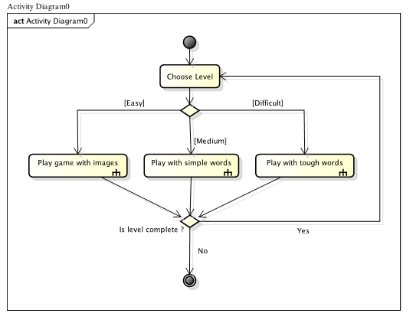

**Main Activity Diagram**

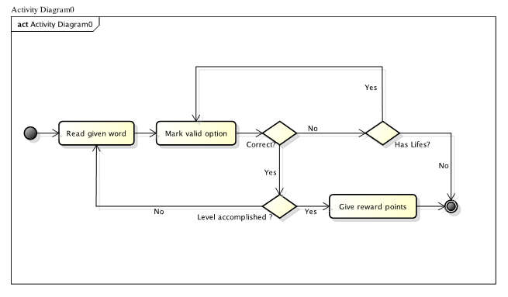

**Activity Diagram**

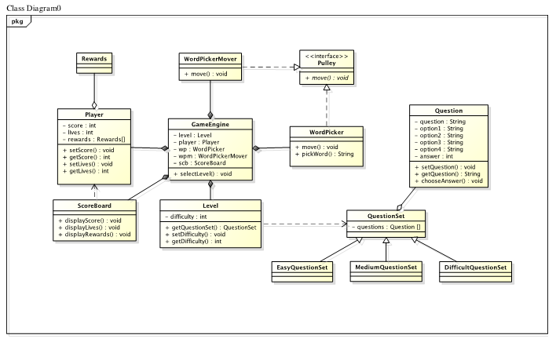

**Class Diagram**

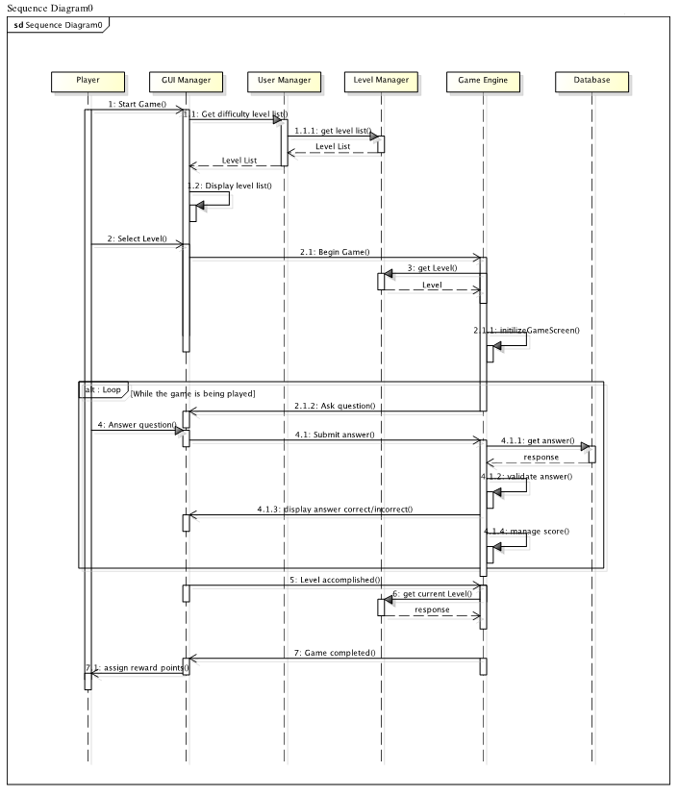

**Sequence Diagram**

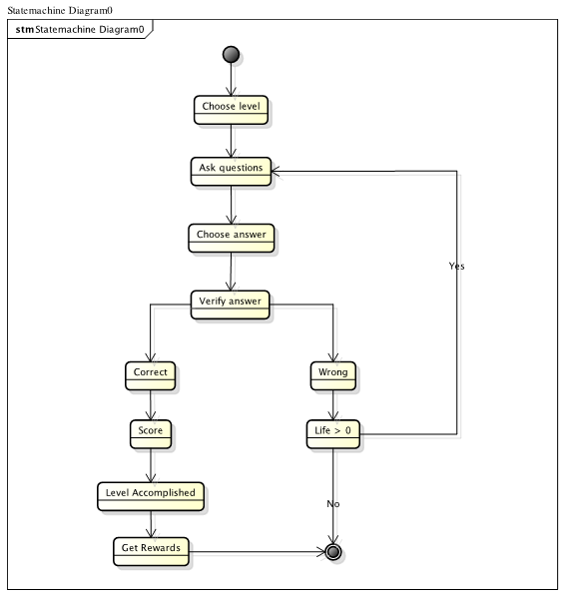

**State Diagram**

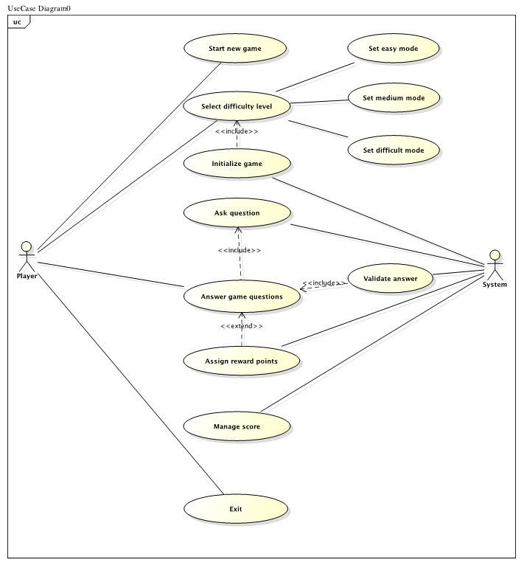

**Use Case Diagram**

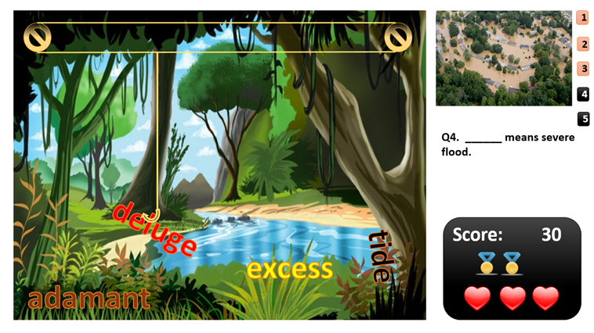

**UI prototype**